**ASSIGNMENT 4**

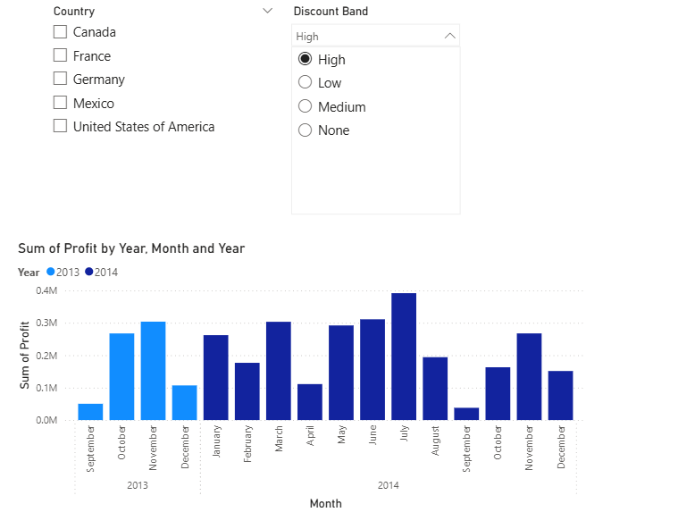

**Steps to create dropdown single select slicer for Discount Band**

* Go to Visualisation Pane🡪Select Slicer.
* Drag and drop the field Discount Band into the slicer’s Field
* By default, the slicer will show as a list. So, to change to Drop-Down format, On the slicer visual, click the down arrow (in the top-right corner of the slicer)🡪Select Drop-Down.
* To enable single select, Select the slicer visual. Go to Format in Visualisation Pane🡪Expand Slicer Settings. Under Selection controls, turn Single select ON.

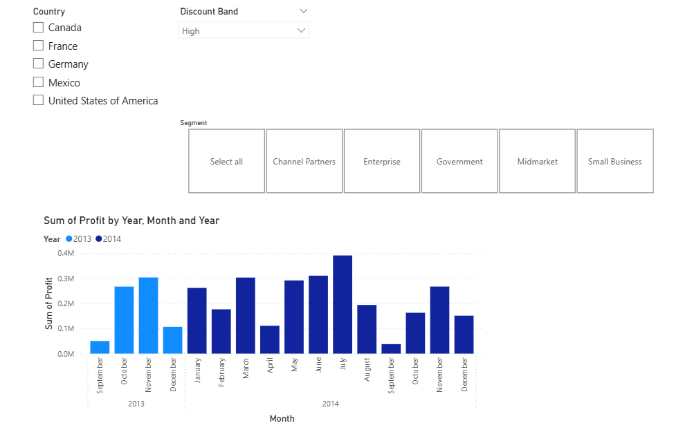

**Steps to create Tile Slicer with select all option for segment**

* From the Visualisation Pane, select Slicer
* Drag the Segment field into the slicer.
* To change to Tile Style, in the Visualisation Pane, go to Format.
* Under Slicer settings🡪Options, change the slicer to Tile style.

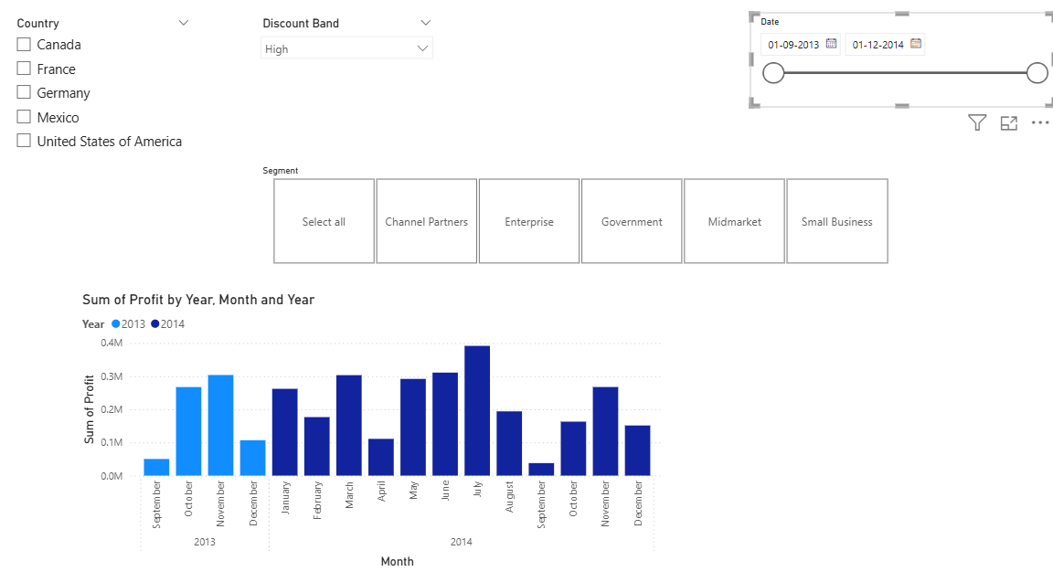

**Steps to create a Slicer for Date**

* Add a Slicer Visual
* Drag the Date Field into the Slicer.

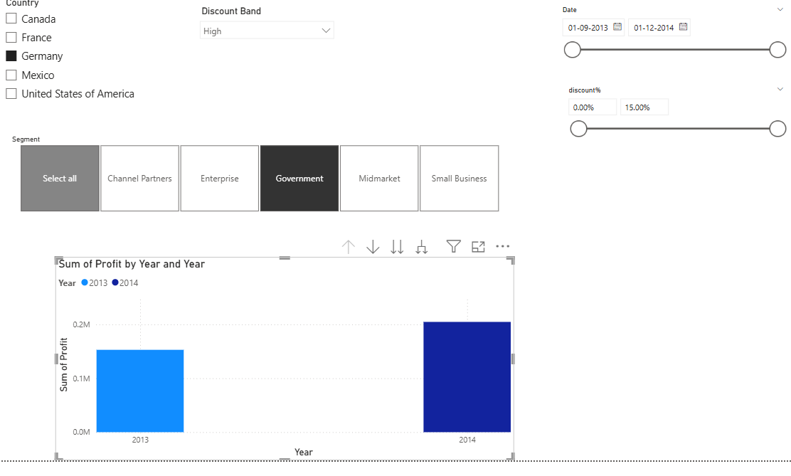

**Steps to create a Slicer for Discount Percentage**

* Add Discount % column in the data.
* To get the Discount percentage Value, insert formula (Discount%=Financial Discount/Financial Gross Sales). Change the values into percentage by clicking on % symbol in the Column tools tab.
* Now add a slicer visual.
* Drag and drop discount % field into the slicer.

**Steps to know the profit of Germany government in the year 2014?**

* Select the country Germany from the country slicer.
* In Segment Slicer, Select only Government option.
* Click on Drill up option, to show profit for the year 2014.